Mental health and crisis support

Mental health issues are becoming more and more common and First Aiders are being called upon to help colleagues, friends, family, and members of the public.
This nationally recognized and comprehensive course is relevant to a wide range of people and provides the learner with essential skills and confidence to recognise and help with a range of mental issues such as depression, anxiety, suicide, and addiction.
COURSE DURATION
St John offers the following delivery options:
- 2 days face to face workshop: This is full face to face course and participants are required to attend both the days.
- 1 day (face to face workshop with pre-work): Participants are required to undertake online e-learning module prior to attending the face to face workshops for practice and assessment.
- Assessment only: This course is for those who are confident in their skills and only want to complete the assessment.
CERTIFICATE
On successful completion of this course you will be issued a statement of attainment in:
- CHCCCS019 Recognise and respond to crisis situations
COURSE OUTLINE
This course covers the following:
- Why do we need first aid for the mind?
- What is a mental disorder?
- Myths and realities
- Action Plan
- Recognising mental health conditions such as: anxiety, depression, bipolar, suicide, trauma and stressors, schizophrenia, and psychotic, eating disorders, substance abuse/addiction, personality disorders, obsessive compulsive.
- Responding to mental health crisis situations.

ASSESSMENT METHODS
A successful outcome for this statement of attainment will be determined by a range of different methods including written assessment, observation of simulated and practical activities etc.
You will be required to demonstrate CPR on a manikin on the floor.
LOCATIONS
St John delivers first aid courses nationally and across many locations in Australia. Choose the location to suit your needs.
- PUBLIC (at a venue near you)
- CUSTOMISED (on-site consultation)
- ONSITE (at a venue of your choice)
- ONLINE (training delivered online from our e-Learning platform)
DELIVERY BY ST JOHN’S RTO PARTNERS
St John Ambulance Australia’s courses are delivered by way of partnership agreements (e.g. with State or Territory St John Ambulance organisations). Our partners are authorised to deliver training on behalf of St John Ambulance Australia Ltd. (TOID 88041). Contact details for our partner organisations are available from www.stjohn.org.au or call 1300 ST JOHN.
PARTICIPANT’S HANDBOOK
Download the Participant’s Handbook from www.stjohn.org.au for more information about completing a course with St John Ambulance Australia. This includes information about complaints, appeals and privacy information.
We actively tailor training to meet the needs of people from diverse backgrounds and abilities and encourage all to apply.
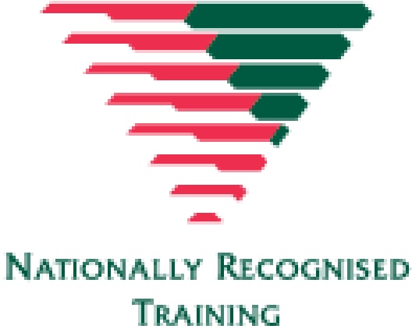
For more information on this course,
contact the Training Office in your area
1300 ST JOHN (1300 785 646) WWW.STJOHN.ORG.AU

